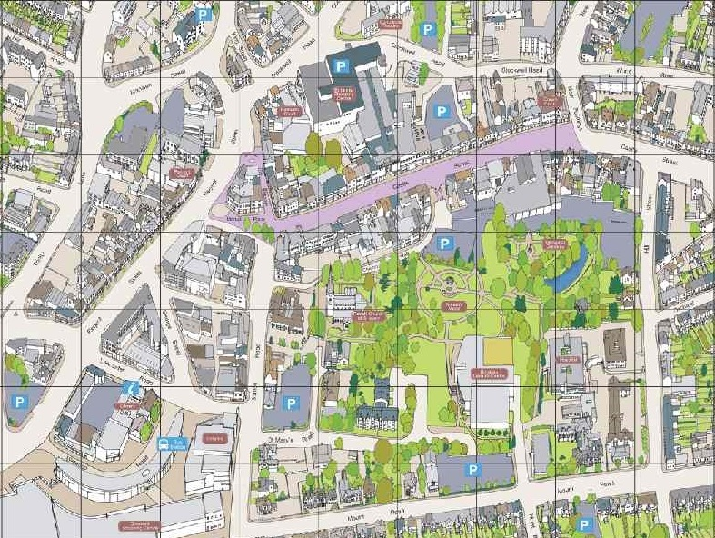

**SWEET STOP**

**Start/FinishMarket Place**

**Hinckley BID & HBBC’s Festive Family Fun Run – Sunday, 5th December 2021  
*Route Map (Distance 0.8 miles)*Start time: 10.45am in Market Place for a fun warm up with our resident healthy elf!**